Java project

PIERSON Ludovic, GOUVENEL Laura, GALLAND Thomas, BOUNAIX Amandine

28/05/2018 – 6/06/2018

**Estimated planning :**

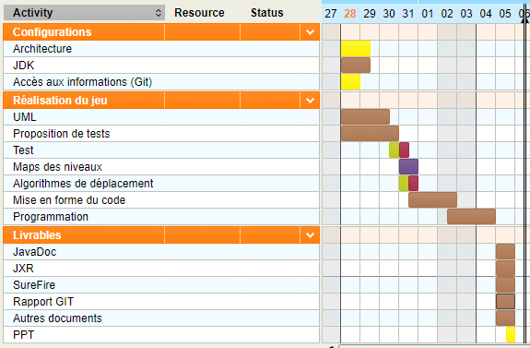

**Effective planning :**

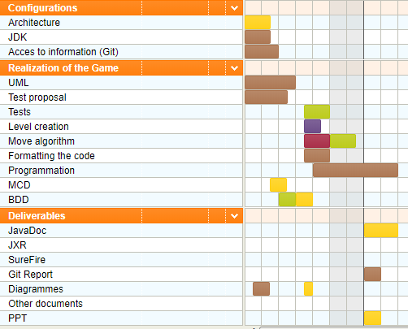

**Gap maping :**

There are differences between these differents planning, because of the difficulties about the establishment of the connexion between github and eclipse ; also maven.

**Assesments :**

Laura :

This project was very difficult and we have had many problems with github and Maven. These problems delay us because we had to restart a git project many times. The group atmosphere was really good.

Ludovic :

I’m agree with Amandine this project are very difficult. I realize i have some difficulties. I am not satisfied with my project. I did different things but I wanted to do more things. I have to work Java during my vacation i think.

Thomas :

We met a lot of difficulties with this project. The first war my bad comprehension of the Java and when we have make the UML, I don't think to the future and to the programme.

We have had also many difficulties with Maven, GitHub and Javadoc who provoked 2 restart of projects.

But my big difficulties was to display a window because I don't have understand the gave code of showboard so I have passed many time to try to create a window.

Amandine :

The project was really difficult, because we had lots of difficulties that slow down the course of our work. I don’t fell satisfied at all, I have lots of gaps in java, so I couldn’t do correctly what we had to do.

Group :

the atmosphere of the group was very good and very pleasant. However, we have all four difficulties for programming in Java. so we had a lot of trouble doing this project.

**JavaDoc :**

**JXR :**

For us, JXR’s rapport, is a rapport of an code optimisation. We don’t have make this rapport because we don’t have finish all the code and we have passed all the time on the code. So we don’t have any time for make this rapport.

**SureFire :**

We don’t have SureFire’s rapport because we don’t have some test. So we can’t make SureFire’s rapport.

**Details of the Data Bases**

For the BDD, we have made a MCD. In this BDD, we have just one table « level ». they are five fields, « id », « id_map », « X », « Y », « Sprite ».

https://cdn.discordapp.com/attachments/451075636555939840/453560763357855747/unknown.png

The contents of the BDD

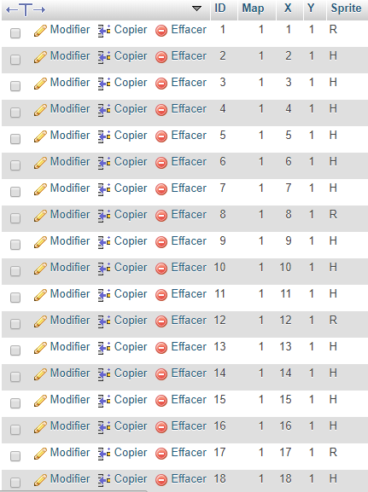

The content of the level’s table.

We have also made a stored procedures. We have use this procedure for recover the BDD in the Java project.

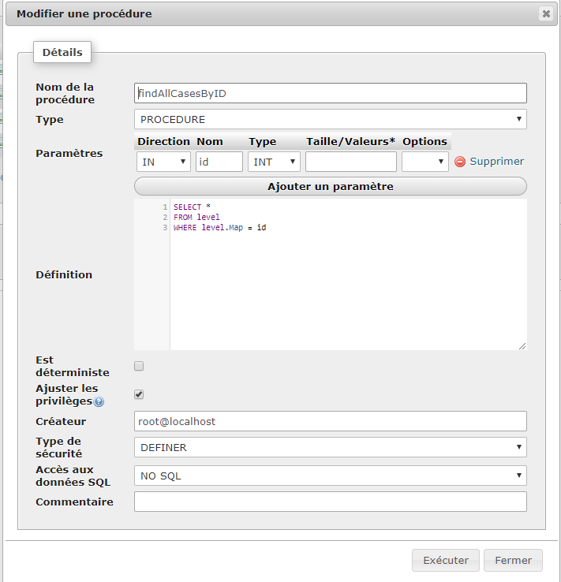

**Obtained result**

So we don’t have the final result. But we have some result. We have a frame but they are empty that is the problem. We just have a white screen on the frame.

We can recover the BDD information for make the maps but we can’t display the map. We display in the console, all information of the map we have choose before.

Our factory work but we can’t use the created objects. We have just put a « println() » for test the factory. We have two factory, one for the motion element and one for the motion less element.

**Sequences diagram :**

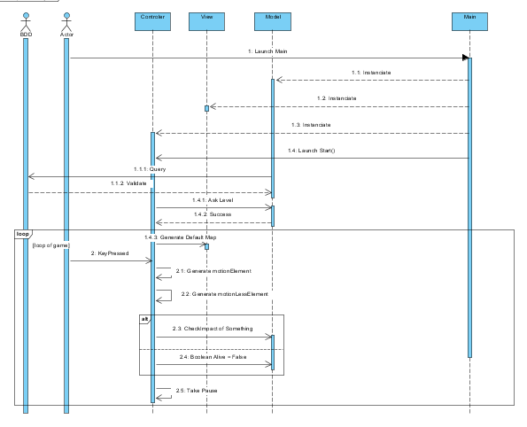

**Component diagram :**

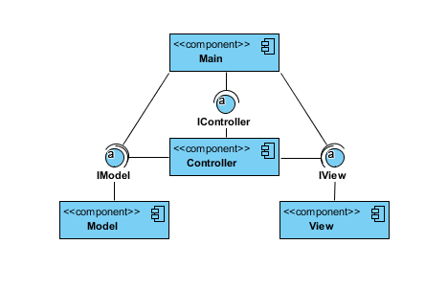

**Package digram :**

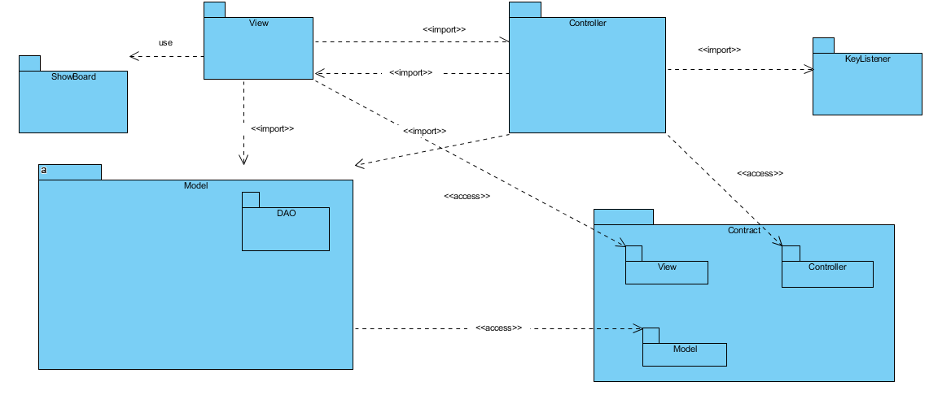

**Class diagram :**

